**Book Recommendation Chatbot: Leveraging NLP and Machine Learning for Personalized Literary Exploration**

*Dissertation submitted in fulfillment of the requirements for the Degree of*

# BACHELOR OF TECHNOLOGY

**IN**

## COMPUTER SCIENCE AND ENGINEERING

By

## Ashish Yadav(12016785)

## Sneha Meena(12015944)

## Ashish Bansal(12014618)

## Tanishq Khandelwal(12017368)

Supervisor

**Mrs. Shivangini Gupta**



**School of Computer Science and Engineering**

Lovely Professional University

Phagwara, Punjab (India)

April,2024

**DECLARATION STATEMENT**

I hereby declare that the research work reported in the dissertation/dissertation proposal entitled " Book Recommendation Chatbot: Leveraging NLP and Machine Learning for Personalized Literary Exploration" in partial fulfilment of the requirement for the award of Degree for Bachelor of Technology in Computer Science specialisation in Data Science and ML at Lovely Professional University, Phagwara, Punjab is an authentic work carried out under supervision of my research supervisor Mrs. Sneha Sharma. I have not submitted this work elsewhere for any degree or diploma.

I understand that the work presented herewith is in direct compliance with Lovely Professional University’s Policy on plagiarism, intellectual property rights, and highest standards of moral and ethical conduct. Therefore, to the best of my knowledge, the content of this dissertation represents authentic and honest research effort conducted, in its entirety, by me. I am fully responsible for the contents of my dissertation work.

## Ashish Yadav(12016785)

## Sneha Meena(12015944)

## Ashish Bansal(12014618)

## Tanishq Khandelwal(12017368)

**SUPERVISOR’S CERTIFICATE**

This is to certify that the work reported in the B.Tech Dissertation/dissertation proposal entitled “**Book Recommendation Chatbot** “ submitted by Ashish Yadav, Sneha Meena, Ashish Bansal, Tanishq Khandelwal at **Lovely Professional University, Phagwara, India** is a Bonafide record of his / her original work carried out under my supervision. This work has not been submitted elsewhere for any other degree.

Signature of Supervisor

(Name of Supervisor)

**Date:**

**Counter Signed by:**

**1) Concerned HOD:**

HoD’s Signature: ________________

HoD Name: ____________________

Date: ___________________

**2) Neutral Examiners:**

**External Examiner**

Signature: _______________

Name: __________________

Affiliation: ______________

Date: ___________________

**Internal Examiner**

Signature: _______________

Name: __________________

Date: ___________________

**List of contents**

|  |  |  |
| --- | --- | --- |
| **S No.** | **Title** | **Page** |
| 1 | Title Page | 1 |
| 2 | DECLARATION STATEMENT | 2 |
| 3 | SUPERVISOR’S CERTIFICATE | 3 |
| 4 | List of Contents | 4 |
| 5 | Abstract | 7 |
| 6 | Problem Statement, | 8 |
| 7 | Background and Goals | 9 |
| 8 | Introduction | 10 |
| 9 | Significance of the Project: | 13 |
| 10 | Literature Review | 15 |
| 11 | Applications and Impact | 17 |
| 12 | Role of Artificial Intelligence in Book Recommendation | 18 |
| 13 | Methodology | 21 |
| 14 | Technology Used | 25 |
| 15 | Psuedo Code | 30 |
| 16 | User Interface | 41 |
| 17 | Discussion | 43 |
| 18 | List of Figures | 44 |
| 19 | Results | 47 |
| 20 | Conclusion | 48 |

1. **ABSTRACT**

Creating a robust e-book recommendation chatbot tailored for stoners involves leveraging NLP techniques and programming libraries like Keras and NLTK. The chatbot utilizes live data from Goodreads.com to offer dynamic and personalized suggestions based on stoners' preferences, with users inputting favorite bands or authors for analysis. Seamlessly integrating NLP, programming skills, and web development, it ensures an innovative approach to book recommendation systems. This enhances stoner engagement through an interactive and responsive interface while providing tailored recommendations, directing users to publications that match their interests and research. Overall, the chatbot optimizes user satisfaction and engagement, combining NLP algorithms and programming expertise to deliver a personalized and user-friendly experience.

Keywords: Book Recommendation, Chatbot, NLP, Personalization, Interactive Interface..

**Problem Statement**

While under the influence, stoners who enjoy reading may find it difficult to find novels that suit their tastes. Conventional book recommendation engines might be overpowering and are ill-equipped to address the unique preferences and mentalities connected to the cannabis experience. Lack of Personalization: Current recommendation systems frequently fall short of accommodating cannabis enthusiasts' distinct tastes. Popularity or critical acclaim may take precedence in these systems, which might not result in a pleasurable, high-induced reading experience.

**Background and Goals**

The goal of this project is to create a cutting-edge chatbot that recommends books to stoners. The chatbot will make use of machine learning libraries and Natural Language Processing (NLP) to:

* Understand Stoner Preferences: The chatbot will use NLP algorithms to interpret user input regarding preferred strains or authors and uncover underlying themes and interests.
* Personalized Suggestions: The chatbot will provide carefully selected book recommendations based on each user's interests, ensuring that their high-quality reading experience is met.
* Dynamic and Data-Driven: The chatbot will continuously deliver fresh discoveries by using real-time data from Goodreads to deliver relevant and current recommendations.

The goal of this project is to create a cutting-edge chatbot that recommends books to stoners. The chatbot will make use of the ability for stoners to communicate, promoting a more pleasurable experience when choosing books.

By seamlessly integrating NLP, machine learning, and web development, this project seeks to create a revolutionary approach to book recommendations for the stoner community. It will not only simplify the process of finding new and exciting reads but also promote increased engagement and satisfaction with literature within this specific user group.

**INTRODUCTION**

The digital age we live in is famous for its information wealth. Browsers will find the material only in real libraries instead of in a flooded sea of digital data. The selection of one specific book from a mass of titles is analogous to the hunt for hidden isle on a map with no guides. While they have their uses, conventional book recommendation systems are mostly based on user reviews or general algorithms that do not take into the account the particular flavor of individual reading preferences. The discontentment may make one uninterested which in turn can steal happiness of reading altogether.  
  
  
This project takes this hardship right on and suggests building an amazing chatbot that provides the readers with the best book recommendations. Conceive of an imaginary coach that will be with you during your literary quest. This novel technique is the bridge between readers and books, hence, we can say that it is the unique and intriguing way of book-discovery.  
  
The interface of the application is humanized by the straight forward communication. The dialogue is there so that you can explain and demonstrate your writing goals naturally and effortlessly—there is no artificial intelligence system here. Goodreads.com data-gathering method is used to make sure that recommendations are relevant for the contemporary and ever developing world of books.  
  
But the magic becomes finer. Tough NLP (Natural Language Processing) algorithms sift through your written works and, patiently, they detect themes and key phrases. They delve beyond the surface, discovering a delicate mesh in tune with your choices of reading. The chatbot can display a list of personalized books because it is that knowledgeable.

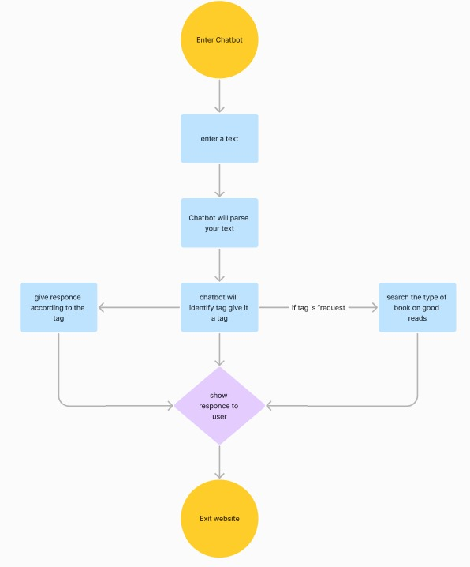

Fig 1. Mindmap for chatbot

This project is a showcase of an interesting merge of expertise putting together data analysis, human understanding (NLP), and in such way, machine learning, data analysis, and user-friendly solutions can be addressed to one problem which goes streched for all of us. Going beyond recommendations, it enchants readers, stimulating their intellectual strength, and demonstrating how valuable and diverse literature can be.  
  
  
This approach which is targeted on users and is based on clear communication, deep understanding makes it possible to find the perfect suitable book whiches brimming with suspense that are waiting to be cracked open.

**Significance of the Project:**

This project has the potential to impact society, industry, and research in several ways:

Society: Increased access to reading for a specific audience: Through this chatbot, it will be possible to eliminate the hindrance of identifying books that resonate with stoners, since these individuals have specific interests or preferences in their niche.

Enhanced engagement with reading: Readers will be able to get their needs and questions answered in real-time as well as participate in the interactive and personalized nature of the chatbot, making reading more enjoyable and engaging for stoners.

Industry: Improved recommendation systems: This project does novelty, where in NLP, user input and live data are being included. This strategy can be adapted not only for creating recommendation systems in e-commerce or entertainment sectors but as well.

Targeted marketing for publishers: Through the analysis of stoners; favorite genres, publishers could design tailored marketing campaigns aimed at young people interested in a particular style of literature.

Research: Advancements in NLP for recommendation systems: This project provides basis for research on the implementation of NLP approach for recommender-system personalization. Data which is collected from users on their preferences and chatbots interactions can fairly help in the field of research.

Understanding user behaviour: The project is going to offer to market researchers, sociologists, and leisure studies fellows a better understanding of stoners' reading habits and preferences that they could utilize for their studies and research.

**LITERATURE REVIEW**

Information about naturally conversational technologies that is NLP, Machine Learning, and Web Scraping are centered here that is the discussion of the literature. We'll look into these systems and see how together they can build a more useful book ratings management.  
  
The natural language processing, or NLP, that make bridges between computer languages and human languages are the key ones in this field. As Haristiani (2019) puts it, approaches like determining tokens and lemmatization are key to the extent that it will break down the user questions and the book content to its specific components which will be comprehended by the AI. Lemmatization operates on the dictionary level and employs a 'root word' that captures the meaning of each word. Tokenization, however, nullifies sentences to individual words. The last consequence of this is that the system can quickly identify different books which are suitable to the user by its meaning. Next, stop word deletion, that is eliminating artless words, will be performed to focus on major terms.  
  
user preferences and the actual books, the latter are core factors as per Andreoni (2023). Using eliminate vocab which are like "the" and "a" that allow it to highlight the more crucial ideas when this is about the book recommendations.  
  
Personalized recommendations are based on algorithms. Machine learning is a power source. To identify any patterns and links exist among user data and book content, machine learning algorithms undertake this obligation. For book suggestions, your systems would use either a Keras model which is a deep learning framework that was studied by Zhang et al. (2020) or a recommendation model from the Bookmarks dataset. Hence this technique works the system can learn from humongous quantity of data and discover connections that are very complex between the fields of characterization and the satisfaction of the readers. The system does this with the help of neural network, through which more personalized and accurate book recommendations are created for every person.

Web scraping acts as a channel to fetched information both from your website and the internet.  
  
system of recommendations. You can put together book information from the likely sources like GoodReads with this feature. The same way of site scraping as set out by Ilamsyah et al. (2019) is the technique used in gathering data for the creation of the initial pool of GoodReads recommendations with user-provided categories setting the input. This initial pool helps a system to start and provides a diversity of publications giving a basis for future individualized recommendations, where the machine-learning and natural-language-processing come into play.  
  
The existing literature of book recommendation algorithms offer insightful revelations about where the direction can be headed. A study by Li et al. (2017) focused on content-based filtering and collaborative filtering with deep learning and natural language processing while Jiang et al. (2018) put more focus on building an advanced system using the mentioned methods. Contrarily, Wang et al. also conducted a study.  
  
Another interesting and innovative approach is the usage of (2019) which provides the possibility to the accuracy of suggestion even more.  
  
The study by Nicolescu and Tudorache (2022) together with the study by Nirala et al. (2022) illustrate this growing significance of AI chatbots as experience of user becomes more and more decisive in the current digital environments. NLP is the interface of your chatbot that allows it to understand the customers' language and provide suggestions plainly, at a conversational level. Thus, this method of book recommendations will become not only active and engaging but also common practice of pleasant communication between readers. With combination of nowadays intelligent technologies and taking into account possible further investigations, it is real to create a robust and user-friendly chatbot for book recommendations. In addition to presenting refined book catalogue with recommendations more-or-less relevant to every user, this approach provides everyone with personalized setting, thus greatly increasing user satisfaction.

**Applications and Impact**

With this e-discovery chatbot customized by stoners, there is several implications that can be observed in both the short and long term.

1. Practical Applications

* Individual Users: When Stoners use the chatbot, they can easily locate books based on genre, author or any related topics of their favourite groups of musicians of writers.
* Bookstores and Libraries: Such organizations would be able to embed the chatbot into their websites or physical branches and consequently the latter would individually recommend users.
* Online Cannabis Communities: The chatbot can be integrated into the in-platform online communities, which are coalesced, or woven, together by stoners, encouraging interaction and the recommendation of new reading materials.

1. Potential Industries and Domains:

* Publishing Industry: publishers are capable of using the data from the chatbot's users to know what interests them and also develop ways of marketing or even writing new book content for them.
* E-commerce Platforms: These platforms can embed the recommendation principle so as to suggest the e-books that are popular among stoners alongside cannabis products or accessories.
* Social Media and Entertainment Platforms: Placing the books on the platform's focus that were frequented by stoners could enable advances in personalized book recommendations within that existing social network.

1. Potential Impact on Society/Industry

* Increased Literacy and Reading Engagement: The chatbot is capable of improving reading interests among stoners qui could bring different socio-cognitive benefits nevertheless.
* Economic Growth for the Publishing Industry: Through promoting the discovery of the new books by stoners, the chatbot can assist in the rise of the book sales and thus have a positive impact on the economics in the publishing industry.
* Environmental Impact: If the guided readings induces people to prefer electronic book to the paper ones, it will definitely have positive effect for the environment because it will result in a decrease of paper usage.

1. Opportunities for Positive Change:

* Promoting Diversity and Inclusion: The recommendation system can be devised to recommend books depicting varying types of characters and perspectives, breaking down stereotyping and instilling characteristics of being inclusive within the stoner community.
* Combating Misinformation: The bot can be programmed to cite links to some authoritative sources and gayevich books especially if the stigma about cannabis sometimes attached to its culture has to be countered.
* Lifelong Learning: The chatbot does that not only by increasing the interest in reading but also by firing up their willingness to explore new ideas and plants the seeds for lifelong learning.

1. Ethical Considerations
2. Privacy Issues:

* User Data Collection: Having the chatbot obtain indicated permission of user collection and using the data solely for the purpose the chatbot is designed to accomplish should be what the chatbot does.
* Data Security: Secure mechanisms like encryption, password protection, and multi-factor authentication must be employed against malicious threats like identity theft and data losses.

1. Bias and Fairness Concerns:

* Algorithmic Bias: Evaluation of the NLP algorithms, used in the chatbot, to eliminate any tendence towards bias against certain genres, authors or views should be done cautiously.
* User Preferences: The recommendation system ought to be created in such a way so as to prevent stereotypes from playing into as well as the users being assigned to a narrow spectrum only according to their initial preferences.

The adoption of these ethical factors will allow the chatbot to be of tremendous help in the realm of stimulating reading engagement and social transformation within the stoner community.

**METHODOLOGY**

1. **Data Acquisition and Preprocessing:**

* The initial step involves acquiring live book data from a reputable source like the Goodreads.com API. This data will encompass book titles, authors, genres, and user ratings, providing a rich foundation for building the recommendation model.
* To ensure data quality, a meticulous preprocessing stage follows. This stage involves techniques like:
  + Removing punctuation, stop words (common words with minimal meaning), and special characters to streamline the textual information.
  + Utilizing NLP techniques like tokenization (splitting text into individual words or phrases) and stemming (reducing words to their base form) to further refine the data and extract valuable features for analysis.

1. **Model Development with Machine Learning:**

* Machine learning algorithms play a pivotal role in the book recommendation model. This project leverages neural networks, implemented using Kera's library, to establish a robust recommendation engine.
* The design of the model architecture is critical. This includes defining input layers that process user queries and output layers that generate book recommendations.
* The core of this stage lies in training the model. The pre-processed data serves as the training material. Hyperparameters, which are essential settings within the model, are meticulously optimized to ensure optimal performance. Additionally, the model architecture itself may be adjusted iteratively to achieve the best possible recommendation accuracy.

1. **Natural Language Processing Integration:**

* NLP is the cornerstone of enabling natural language interaction with the chatbot. Specific techniques are implemented to analyze and comprehend user queries effectively.
* Named entity recognition (NER) is employed to identify key entities mentioned by the user, such as authors, genres, or specific themes. This allows the chatbot to understand the user's specific interests.
* Sentiment analysis can also be incorporated to gauge the user's emotional preferences. For example, a user expressing a desire for an "uplifting" read would receive recommendations that differ from those seeking a suspenseful thriller.
* Finally, sophisticated algorithms are developed to match user preferences gleaned from NLP analysis with the corresponding book attributes within the dataset. This ensures that recommendations align with the user's unique literary interests.

1. **Use User Interface with Streamlit:**

* **Streamlit App Development:** Develop a user-friendly interface using Streamlit. This lightweight framework simplifies the creation of interactive web apps in Python.
* **Input Fields:** Design intuitive input fields for users to specify their book preferences. This could include dropdown menus for selecting genres, text boxes for entering author names, or keyword input fields.
* **Real-time Recommendations:** As the user interacts with the interface, the Streamlit app should dynamically display the generated book recommendations in real time. Each recommendation can include details like a book title, author, and a brief synopsis.

1. **Evaluation and Testing - Ensuring Accuracy and User Satisfaction:**

* Evaluating the effectiveness of the chatbot is essential.
* This involves conducting comprehensive testing to assess the model's accuracy and its ability to generate relevant and personalized recommendations based on user queries.
* User feedback plays a critical role in refining the system. Surveys or usability studies are conducted to gauge user satisfaction and identify areas for improvement. This feedback loop allows for continuous improvement of the chatbot's performance.

1. **Deployment and Maintenance - A Sustainable Solution**

* Once thoroughly tested and refined, the book recommendation chatbot is deployed to a live environment. This makes the system accessible to users through a web interface, empowering them to embark on their personalized literary journeys.
* Monitoring the chatbot's performance and user interactions is an ongoing process. Addressing any technical issues or bugs that arise ensures a seamless user experience.
* The success of the recommendation system hinges on its ability to adapt and evolve. Continuous updates to the underlying algorithms and data sources are vital. This ensures that the chatbot remains effective in delivering high-quality recommendations over time, catering to the ever-changing dynamics of the literary landscape.

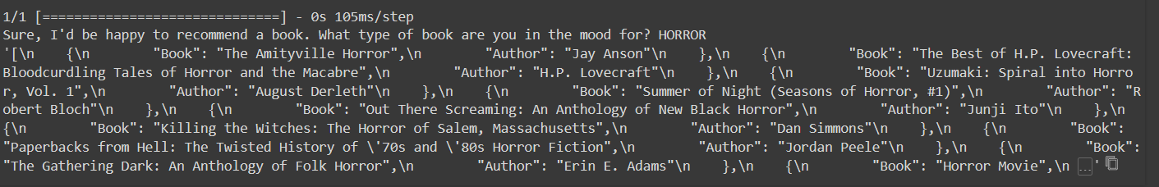

**Technology used.**

This chatbot for book recommendations employs a fascinating combination of technologies. Let's delve deeper into each one:

**1. Web Scraping with BeautifulSoup:**

**Web scraping** is the process of gathering information from the Internet. Even copying and pasting the lyrics of your favorite song is a form of web scraping! However, the words “web scraping” usually refer to a process that involves automation. [Some websites don’t like it when automatic scrapers gather their data](https://realpython.com/podcasts/rpp/12/), while others don’t mind.

If you’re scraping a page respectfully for educational purposes, then you’re unlikely to have any problems. Still, it’s a good idea to do some research on your own and make sure that you’re not [violating any Terms of Service](https://benbernardblog.com/web-scraping-and-crawling-are-perfectly-legal-right/) before you start a large-scale project.

Let's say you're a surfer who is looking for work and you surf both in real life and online. But you're not just looking for any old job. Thinking like a surfer, you're only waiting for the right chance to present itself!

There is an employment site with just the positions you are looking for. Regretfully, there are rarely any new positions posted on the website, and there is no email notification feature. You consider checking in on it daily, but it doesn't seem like the most enjoyable or effective use of your time.

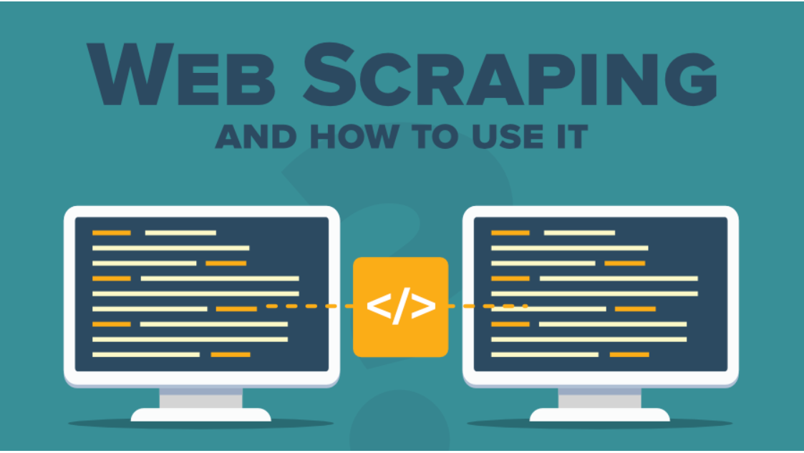

Fig 2. WEB SCRAPING

* The scrape_goodreads function exemplifies web scraping. It utilizes requests to fetch the HTML content from GoodReads based on a search category. Then, BeautifulSoup parses the HTML, finds elements containing book titles and authors (likely based on class names), and extracts the text data to populate your initial set of book recommendations.

**2. Natural Language Processing (NLP) with NLTK:**

* NLP is a field of computer science concerned with the interaction between computers and human language. It involves techniques for understanding and manipulating natural language data.
* NLTK (Natural Language Toolkit): This is a popular Python library providing a suite of tools for NLP tasks. It offers functionalities for:
  + **Tokenization:** Splitting sentences into individual words.
  + **Lemmatization:** Reducing words to their base form (e.g., "running" becomes "run"). This helps improve matching between user queries and the chatbot's vocabulary.
  + **Stop Word Removal:** Eliminating common words with little meaning in the context of book recommendations (e.g., "the", "a").
  + **Part-of-Speech Tagging:** Identifying the grammatical function of words (e.g., noun, verb, adjective).
  + **Named Entity Recognition:** Extracting named entities like people, organizations, and locations.

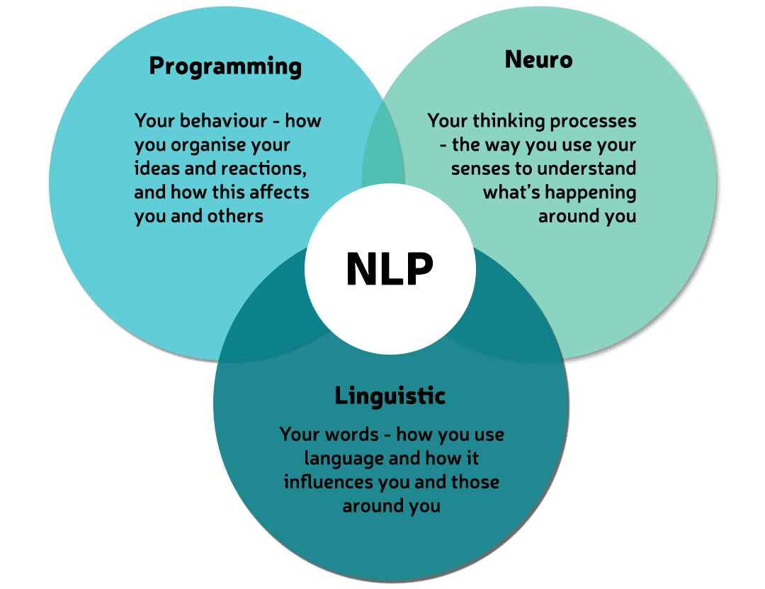

Fig 3. Natural Language Processing (NLP)

* The clean_up_sentence and bow functions leverage NLTK for text processing. They perform the following:
  + **Tokenization:** Break down user messages into individual words.
  + **Lemmatization:** Convert words to their base form using a lemmatizer, ensuring a more consistent vocabulary for the machine learning model.
  + **Stop Word Removal:** Eliminate stop words using a predefined list to focus on words with meaning for book recommendations.
  + **Bag-of-Words Representation:** The bow function creates a numerical vector ("bag of words") to represent a user's message. This vector indicates the presence and frequency of words in the message, providing a numerical representation suitable for machine learning algorithms.

**3. Machine Learning with Keras:**

* Machine learning is a field of computer science that allows computers to learn from data without explicit programming. Keras is a deep learning framework built on top of libraries like TensorFlow that simplifies building and training neural network models. The purpose of Keras is to give an unfair advantage to any developer looking to ship Machine Learning-powered apps. Keras focuses on debugging speed, code elegance & conciseness, maintainability, and deployability. When you choose Keras, your codebase is smaller, more readable, and easier to iterate on.
* **Keras for Intent Classification:** Code defines a multi-layered neural network model using Keras. This model is trained on a dataset where user messages are mapped to specific intents (e.g., "book_search", "greetings"). The training process allows the model to learn patterns that distinguish between different intents based on the words used in user messages.

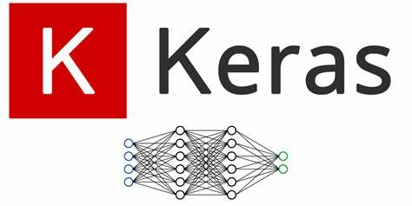

Fig 4. ML with Keras

* The predict_class function utilizes the trained Keras model. It takes a user message as input, preprocesses it using the NLP techniques mentioned earlier (tokenization, lemmatization), and creates a bag-of-words representation. This numerical representation is fed to the trained model, which predicts the most likely intent associated with the user message. Based on the predicted intent, the chatbot chooses the appropriate response (e.g., initiating a book search or providing a greeting message).

**4. Text Processing and Data Manipulation with pandas and NumPy (potentially):**

**• pandas:** This library covers data structures and data analysis tools. It would be not directly used in the supplied code snippet, but could be helpful for initial data loading and manipulation, especially for the training dataset for machine learning model (supposed to be CSV file containing user messages with their corresponding intents).  
  
• **NumPy:** This library gives numerical computing operations. In the context of machine learning, NumPy arrays are usually used to compactly store train data. This transformation is most likely being utilized to convert the processed text data (e.g., bag-of-words) into numeric arrays, which are the model's input**.**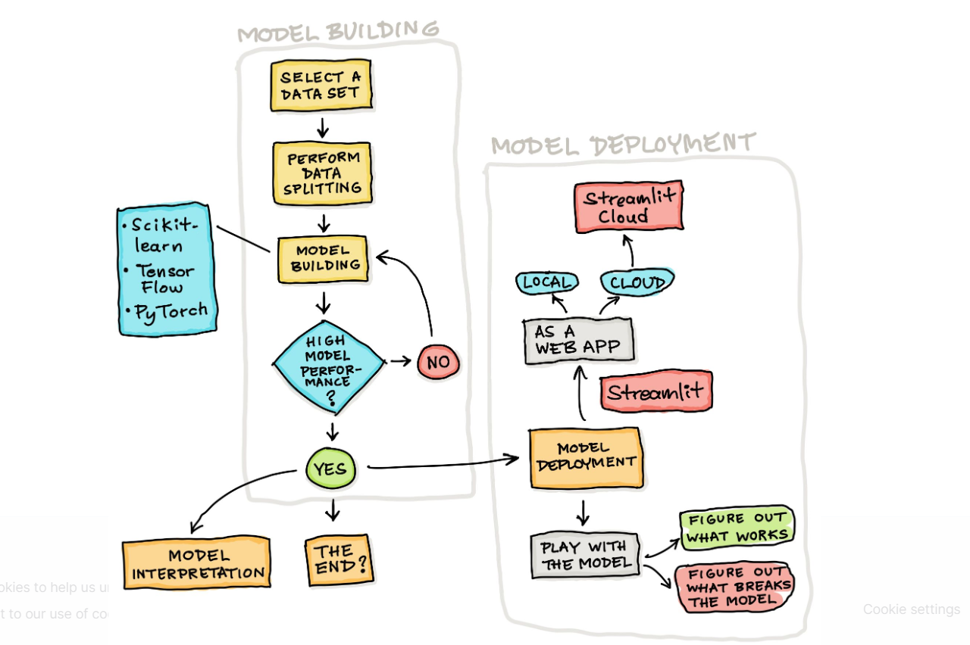

FIG 5. Streamlit

**Pseudocode**

* A black rectangular object with a white border

  Description automatically generated
* Utilizes several libraries to perform web scraping and data manipulation.
* A screenshot of a computer

  Description automatically generated

Here we define a function to scrape book information from Goodreads based on a provided category. It constructs a search URL for Goodreads, downloads the content, parses the HTML using Beautiful Soup, extracts book titles and author names, and builds a JSON containing a list of dictionaries with book and author information for each entry.

* 

prompts the user to enter a category (book name, genre, or author) for searching for books on Goodreads.

* A black screen with white text

  Description automatically generated

The provided code snippet suggests an introduction to Natural Language Processing (NLP). It imports libraries like nltk for tasks like sentence segmentation and converting words to their base form (lemmatization). Additionally, the inclusion of Keras libraries hints at the potential for building a machine learning model for text analysis, though the specific architecture details might be beyond the course's scope.

* The first line opens a file named "capstoneIndentPart1.json" in read mode and stores the entire content of the file in the data_file variable.

intents = json.loads (data_file): This line assumes the data in data_file is formatted in JSON (JavaScript Object Notation). It uses the json. loads function to convert the JSON string into a Python dictionary. This dictionary, likely containing information about user intents and chatbot responses, is stored in the variable intents.

* A black rectangular object with white text

  Description automatically generatedIt creates empty lists named words, classes, and documents. These lists will likely be used to store processed text data for training a machine learning model. It defines a list named ignore_words containing punctuation marks like '?' and '!'. These characters might be removed from the text data during preprocessing to improve the model's focus on meaningful content.

* In preparation for training a machine learning model for an NLP application, this code processes text data from a loaded JSON structure. It iterates through each intent's patterns (sentences) and tokenizes the words using nltk. word_tokenize. These words are then added to a vocabulary list (words) and used to build the model's understanding of language. Additionally, each pattern is paired with its corresponding intent tag (intent['tag']) and stored in a document list, creating a collection of text-intent examples for training. The code also keeps track of unique intent tags (representing different categories) and stores them in a class list. To ensure a clean and effective vocabulary, the code performs further processing after iterating through all patterns. It lemmatizes each word in the vocabulary list (converting them to their base form) using the lemmatizer. It then removes punctuation marks listed in ignore_words and eliminates duplicate words, resulting in a refined vocabulary focused on meaningful content. Finally, both the vocabulary and the identified intent classes are sorted alphabetically for better organization. The code concludes by printing informative statistics about the processed data, including the number of documents (text-intent pairs), the size of the unique word vocabulary, and the identified intent classes.

* This code prepares the actual training data for the machine learning model. It iterates through each document-intent pair (doc) in the documents list. For each document (text pattern), it creates a "bag of words" representation. This involves creating a list (bag) where each position corresponds to a word in the vocabulary (words). The value at each position in the bag is set to 1 if the corresponding word appears in the document, and 0 otherwise. This essentially captures the presence or absence of words in each document. Finally, the bag of words along with the corresponding intent tag (doc[1]) from the document are combined and appended to a training_data list, creating a collection of input (bag of words) and output (intent tag) pairs for training the model.

The code then identifies the longest document (represented by its bag of words) in the training data and uses that length (max_length) as a standard. It pads shorter documents with zeros ('constant') to ensure all inputs have the same size for the model. This padding ensures a consistent data format during training. Finally, the code converts the processed training data (bags of words and intent tags) into a NumPy array (training) for efficient handling by the machine learning model.

* It iterates through each document-intent pair (doc) in the documents list. For each document, it creates a "bag of words" representation (bag) as before, identifying the presence (1) or absence (0) of words in the vocabulary. To represent the desired output (intent class) for each document, it creates a list (output_row) filled with zeros (output_empty) with a length matching the number of classes (len(classes)). This list essentially acts as a one-hot encoded vector where only the element corresponding to the document's intent class (doc[1]) is set to 1. This approach efficiently encodes the target class for the model. The code shuffles the entire training data (training) using random. shuffle to improve the model's generalization by exposing it to examples in random order. Finally, it converts the training data (a list of lists) into NumPy arrays for efficient processing by the model. It separates the input features (bag of words) and target classes (train_x and train_y) and ensures they are converted to NumPy arrays correctly using list comprehension. The code concludes by printing the shapes of the resulting training data arrays (train_x and train_y) to confirm their dimensions. This helps verify that the data is properly formatted for training the machine learning model.
* A screen shot of a computer code

  Description automatically generatedThis code defines the architecture and training parameters for a neural network model using the Keras library. It creates a sequential model (Sequential) with several layers. LIKE - **Dense layers:** These are fully connected layers with a specific number of neurons (128 and 64 in this case). The first layer (Dense(128, input_shape=(len(train_x[0]),), activation='relu')) defines the input layer size based on the length of the bag-of-words vectors (train_x[0]). Each layer uses the ReLU (Rectified Linear Unit) activation function for non-linearity.

**Dropout layers:** These layers (Dropout(0.5)) randomly drop out 50% of the neurons during training to prevent overfitting and improve model generalization.

**Output layer:** The final layer (Dense(len(train_y[0]), activation='softmax')) has several neurons equal to the number of intent classes (len(train_y[0])) and uses the softmax activation function to produce probability distributions over the classes (indicating the likelihood of each intent class for a given input).

The code then defines a Stochastic Gradient Descent (SGD) optimizer with specific learning rate (lr=0.01), momentum (momentum=0.9), and Nesterov momentum (nesterov=True) parameters to control how the model updates its weights during training. Finally, it compiles the model by specifying the loss function (categorical_crossentropy suitable for multi-class classification), the optimizer (sgd), and the metric (accuracy) to track the model's performance during training.

* A computer screen with white text

  Description automatically generatedThis code snippet trains and saves the machine learning model. It uses the model.fit function to train the model on the prepared training data (train_x and train_y). The model is trained for 500 epochs (epochs=500), meaning it will iterate through the entire training data 500 times. It processes the data in batches of 5 (batch_size=5) for efficiency. The verbose=1 parameter provides basic progress information during training.

After training, the code saves the trained model using model.save('chatbot_model.h5') for future use. The saved model file (.h5 extension) can be loaded later to make predictions on new text data. Finally, it prints a message indicating successful model creation.

* A computer screen shot of a black background

  Description automatically generatedThis code defines a function clean_up_sentence that preprocesses a sentence for your NLP application. It first splits the sentence into words using tokenization. Then, it iterates through each word, converting it to its base form (lemmatization) using a lemmatizer and converting it to lowercase for consistency. Finally, it returns the cleaned sentence as a list of lemmatized and lowercase words
* A screen shot of a computer program

  Description automatically generated

This code defines a function named bow (which likely stands for "bag of words") that creates a representation of a sentence based on the vocabulary. Here's how it works:

1. **Preprocessing:**
   * It starts by calling the clean_up_sentence function (explained earlier) to tokenize the sentence (split into words) and lemmatize/lowercase each word. This ensures consistent word representation.
2. **Bag of Words Creation:**
   * It creates a bag of words representation (bag) as a list of zeros, with a length matching the size of the vocabulary (len(words)).
   * It iterates through each word in the cleaned-up sentence (sentence_words).
   * For each word, it compares it to every word in the vocabulary (words). If a match is found, the corresponding position in the bag list is set to 1, indicating the presence of that word in the sentence.
   * The show_details parameter (default True) allows for optional printing of each found word during processing.
3. **Output:**
   * Finally, the function returns a NumPy array (np.array(bag)) representing the bag of words for the sentence. This array essentially captures which words from the vocabulary are present in the sentence.

* 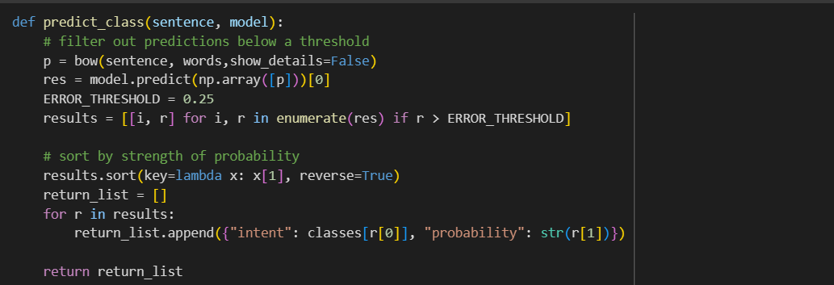

This code defines a function predict_class that takes a sentence and the trained model as input and predicts the most likely intent class for the sentence. Here's a breakdown:

1. **Sentence Representation:**
   * It first calls the bow function (explained earlier) to create a bag-of-words representation (p) for the sentence. This captures the presence or absence of words from the vocabulary in the sentence.
2. **Model Prediction:**
   * It converts the bag-of-words representation to a NumPy array (np.array([p])) and feeds it to the model's prediction method. The model predicts probabilities for each possible intent class based on the sentence's representation.
3. **Filtering and Sorting:**
   * It defines an ERROR_THRESHOLD (default 0.25) to filter out low-confidence predictions. Only predictions with probabilities exceeding this threshold (r > ERROR_THRESHOLD) are considered.
   * The remaining predictions are stored in a list (results) along with their corresponding class index (i) and probability (r).
   * This list is then sorted in descending order based on the predicted probability (r[1]), ensuring the most likely classes appear first.
4. **Building the Output:**
   * An empty list (return_list) is created to store the final output.
   * The function iterates through the sorted predictions (results) and for each one, it creates a dictionary with two key-value pairs:
     + "intent": This key stores the actual intent class name obtained from the class list (classes[r[0]]) using the predicted class index.
     + "probability": This key stores the predicted probability for that class as a string (str(r[1])).
   * These dictionaries are appended to the return_list.
5. **Returning the Results:**
   * Finally, the function returns the return_list containing dictionaries for the most likely intent classes (along with their probabilities) for the given sentence. This information can be used by your application to determine the most suitable response based on the predicted intent.

* A computer screen with text

  Description automatically generatedThis function, getResponse, takes the predicted intent (ints) and the loaded JSON data (intents_json) containing information about intents and responses. It extracts the intent tag from the first prediction in ints. It then iterates through the list of intents in the JSON data to find the matching intent based on the tag. If a match is found, the code checks for a special case: "book_search" intent. If it's a book search request, it prompts the user for a category and calls a function (scrape_goodreads) to potentially retrieve recommendations. Otherwise, it randomly selects a response from the matched intent's list of predefined responses stored in the JSON data. Finally, the function returns the chosen response (either a user-prompted recommendation or a random response from the matched intent).
* 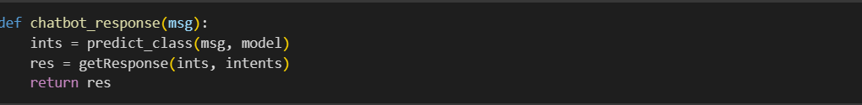**Intent Prediction:** It calls the predict_class function, passing the message and the trained model (model). The predict_class function analyzes the message and predicts the most likely intent class (user's goal) based on the model's understanding.

**Response Retrieval:** It takes the predicted intent information (ints) and the loaded JSON data (intents) containing pre-defined responses for various intents. It then calls the getResponse function with these arguments.

**Response Selection:** The getResponse function identifies the user's intent based on the prediction and retrieves the appropriate response from the JSON data. Here's where the logic gets interesting:

If the intent is "book_search," it prompts the user for a specific category and potentially retrieves book recommendations using a function named scrape_goodreads (presumably for scraping data from a book website).

Otherwise, it randomly selects a pre-defined response from the list associated with the predicted intent in the JSON data.

* OUTPUT:

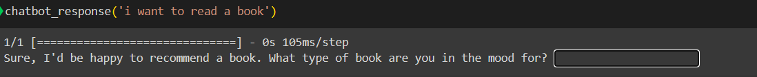



**USER INTERFACE**

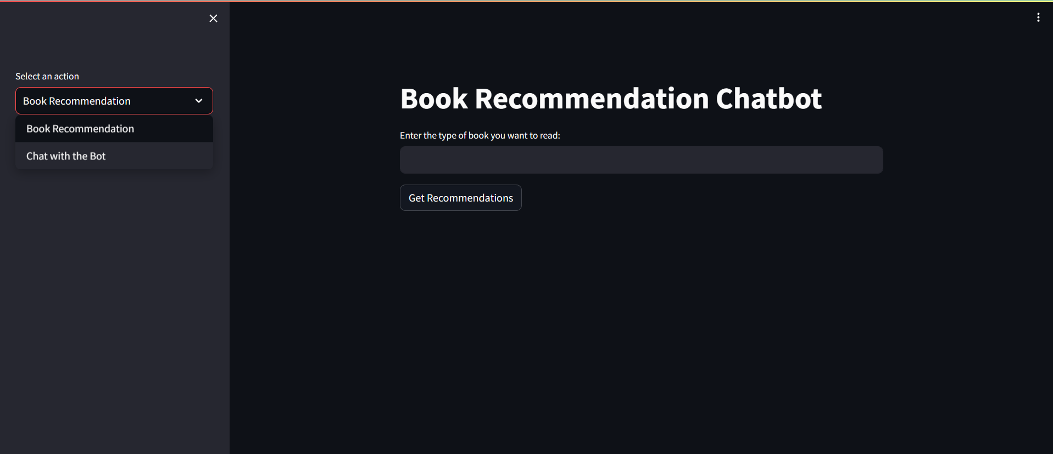

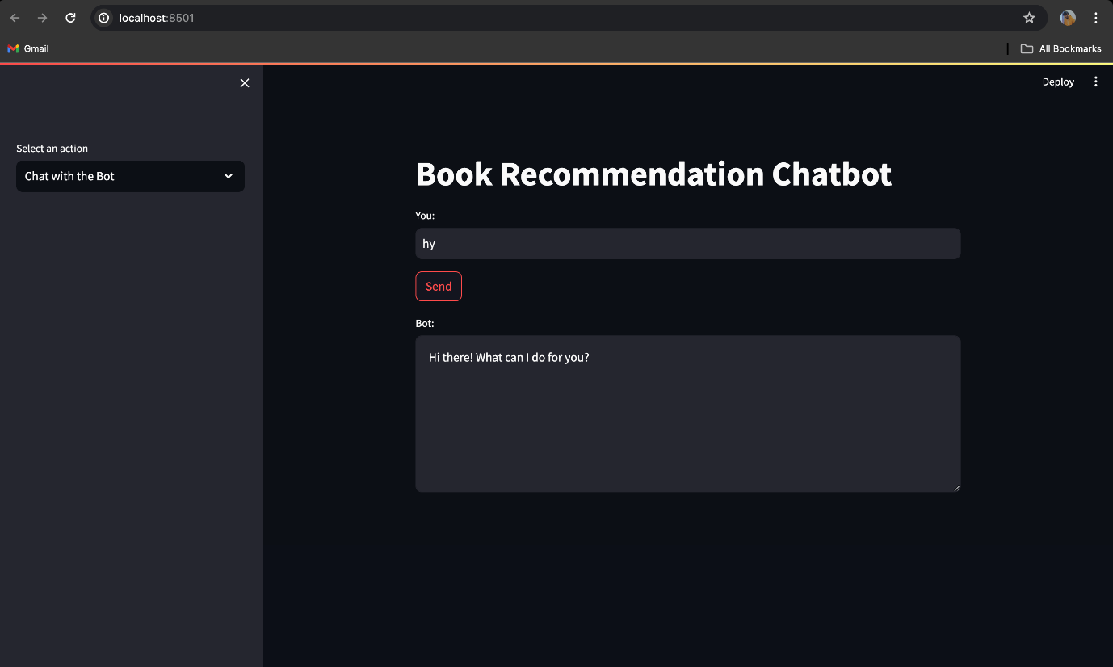

**Discussion**

* Implications of the Results: Evaluate whether any trends emerge in terms of user interactions with the chatbot, their habits of reading post-recommendation, as well as any collected data; the pertinent stoner tendencies and book discovery patterns should be revealed in this regard.
* Practical Significance: Mention the positive effects of the chatbot towards user engagement, reading habits within the stoner community, and if such is the case, the benefits to the publishing and/or e-commerce industry.
* Achievement of Project Goals: Analyse whether the chatbot is focusing on meeting its initial aims or not! Is it giving personalized recommendations? Is it enhancing user satisfaction? Is it promoting reading engagement among different stoners?
* Alignment with Initial Objectives: Define which particular areas of the project did not achieve the intended target and explain why it didn't happen and what are the consequences.
* Theoretical Contributions: Talk how the project is important to NLP field by applying the NLP techniques for the context of user’s personalized recommendation in a specific user group.
* Constraints and Challenges Faced: Highlight any tech barriers, data touch points, or unforeseen obstacles found while perfecting the prototype.

**LIST OF FIGURES**

|  |  |  |
| --- | --- | --- |
| S.NO | DESCRIPTION | PAGE NO |
| FIG 1. | Mindmap For Chatbot | 9 |
| FIG 2. | Webscraping | 24 |
| FIG 3. | NATURAL LANGUAGE PROCESSING (NLP) | 25 |
| FIG 4. | ML with Keras | 26 |
| FIG 5. | Streamlit | 27 |

**Future Scope**

The advanced book recommendation Chatbots in this industry lay a solid foundation for both growth and expansion in multiple directions.

1. Enhanced recommendation system: future iterations of the chatbot may include advanced recommendation systems, with hybrid techniques that include collaborative filtering, content-based filtering, and in-depth knowledge of techniques plus, person demographics, reading history, and social interactions are included as recommendations accuracy can be further improved by combining reference reports.

2. Multi-modal recommendations: Incorporation of multi-modal data sources, including e-book summaries, opinions, and multimedia content (e.g., audio samples, video presentations), in order to ensure that the counselling process remains comprehensive for clients and provides feedback for logic books.

3. Personalization and customization: Chatbots will be better at delivering more personalized signals by continuously learning from human interaction and feedback. Using reinforcement recognition or online recognition algorithms can allow a chatbot to adapt and improve its instructions over time, especially based on customer preferences and evolving trends.

4. Integration with E-Business Platforms: Integration of chatbots with e-commerce infrastructures or on-line bookstores enables users to purchase supported books instantly through the interface, giving them consumption the role is more exciting and creates new sales channels.

5. Cross-area Recommendations: Expanding the scope of guidelines beyond books to consist of related media consisting of films, podcasts, or articles should broaden the chatbot's application and appeal to a wider target audience with various interests.

6. Natural Language Understanding: New advances in natural language understanding (NLU) capabilities want to enable chatbots to capture and formulate complex human queries, including conversational interactions and unambiguous requests, and provide conversational interest increases.

7. Accessibility and Multilingual Support: The use of accessibility features in combination with voice input/output and display reader engagement makes chatbots extra inclusive and within the reach of customers with disabilities. Additionally, adding support for multiple languages ​​will cater for yet another variety of user interfaces. eight. User engagement and gamification: Game elements that offer catchy badges, challenges, or rewards with a chatbot to search for recommended books should engage users and they are preserved, giving them a sense of progress and leisure .

8. Accessibility and Multilingual Support: Implementing accessibility features such as voice input/output and screen reader compatibility would make the chatbot more inclusive and accessible to users with disabilities. Additionally, adding support for multiple languages would cater to a more diverse user base.

**Result**

This explains why by using sequential learning approaches and a collaborative model the sources of recommendation systems have become simple and accurate. The system consists of three main components: for example, web scraping for an automatic data assortment of books, NLP for detailed users' text treatments, and neural network for recommendation generation which implies a recommended selection of books for users by their preferences. The method of working in increments makes a model easily adjust and converge. Consequently, the model creates fine}-tuned predictions and accurate results through user feedback and the application of its prediction. On top of that, the collaborative filtering algorithm is used to estimate the general behavior of users, and, at this stage, these estimates are used to detect patterns and signals. To be honest, besides learning from these models’ readers may discover surprising book titles through these suggestions. The evaluation criteria, recommendation accuracy, user engagement, and to success in user satisfaction which is the goal of the project are some of the parameters that drive the assessment of the presented book discovery system.

**Conclusion**

In summary, the one-of-a-kind system and the model of tailored recommendation for books have emphasized yet highlighted the feasibility of data integration and the usefulness of using both sequential learning and collaborative filtering methods to come up with various recommendation systems for individualized recommender systems. Customization of deep learning outputs is only achievable by using users' distinctive eating habits and food-related preferences along with their restrictions as inputs for the system in the likelihood that the system will keep getting new recommendations that are highly responsive to real-life app users' mixture of search. Doing this also vastly increases the effectiveness since the recommender engine gets merged with other group user behavior and although it provides very accurate information it is more likely to be a part of, or even a complete of the person's group that they either directly or indirectly joined. It was obvious that such future research activities as the refinement of neural network algorithms, expansion of the dataset sizes, and user feedback collecting would promote the book recommender system and hence the level of automation. The first knowledge-based system developed was for the finding of new books. Hence, I got an opportunity to develop a platform that is mindful and lets the customers decide for themselves.